PROJECT 1:

Deploying a web server in Windows instance

Task 1:Create a windows instance using AMI: Windows 2012 R2 base

Task 2:Launch the Windows instance using RDP

Task 3:Install IIS web server using Powershell ISE

Note: Simply copy the command below and paste in the PowerShell ISE to install the IIS web server.

!!!!Powershell is case sensitive.

Install-WindowsFeature -name Web-Server -IncludeManagementTools

Task 4:Verify successful installation of IIS Web Server

Note: You should be able to see the Internet Information Services Web page when you paste the public IP

into the browser.

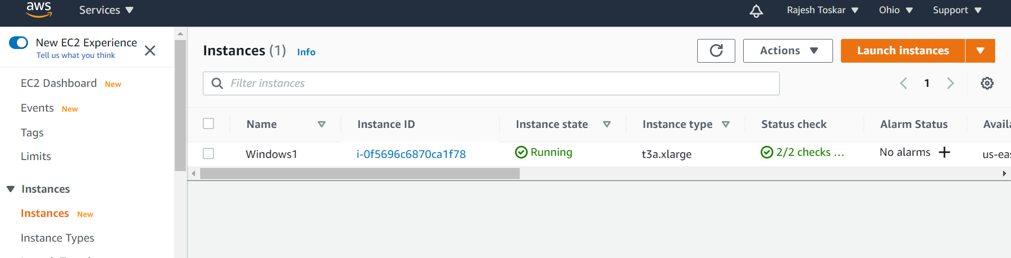

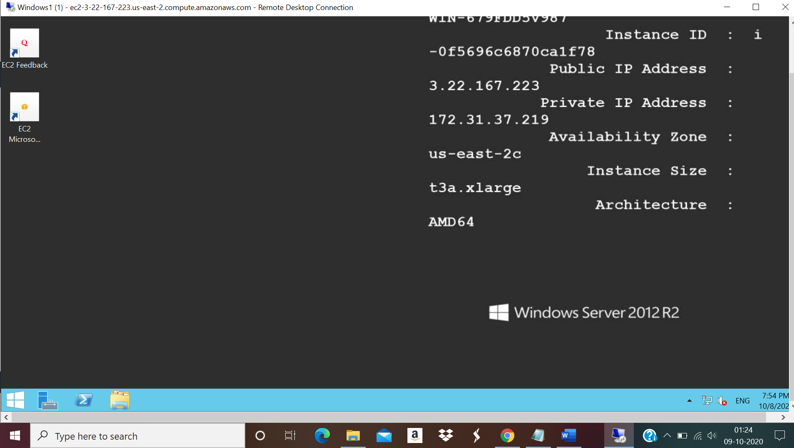

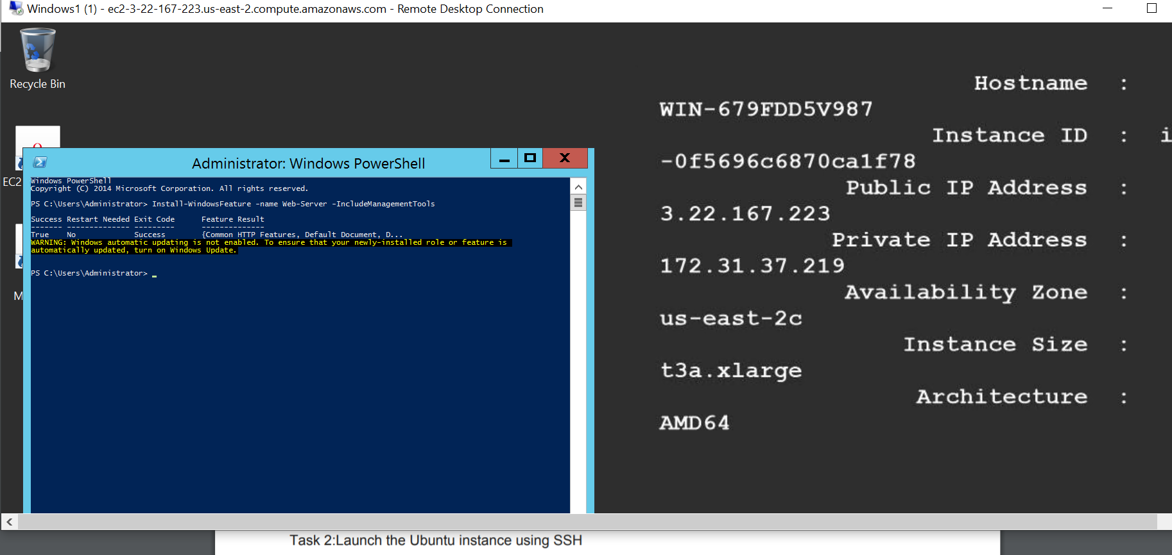

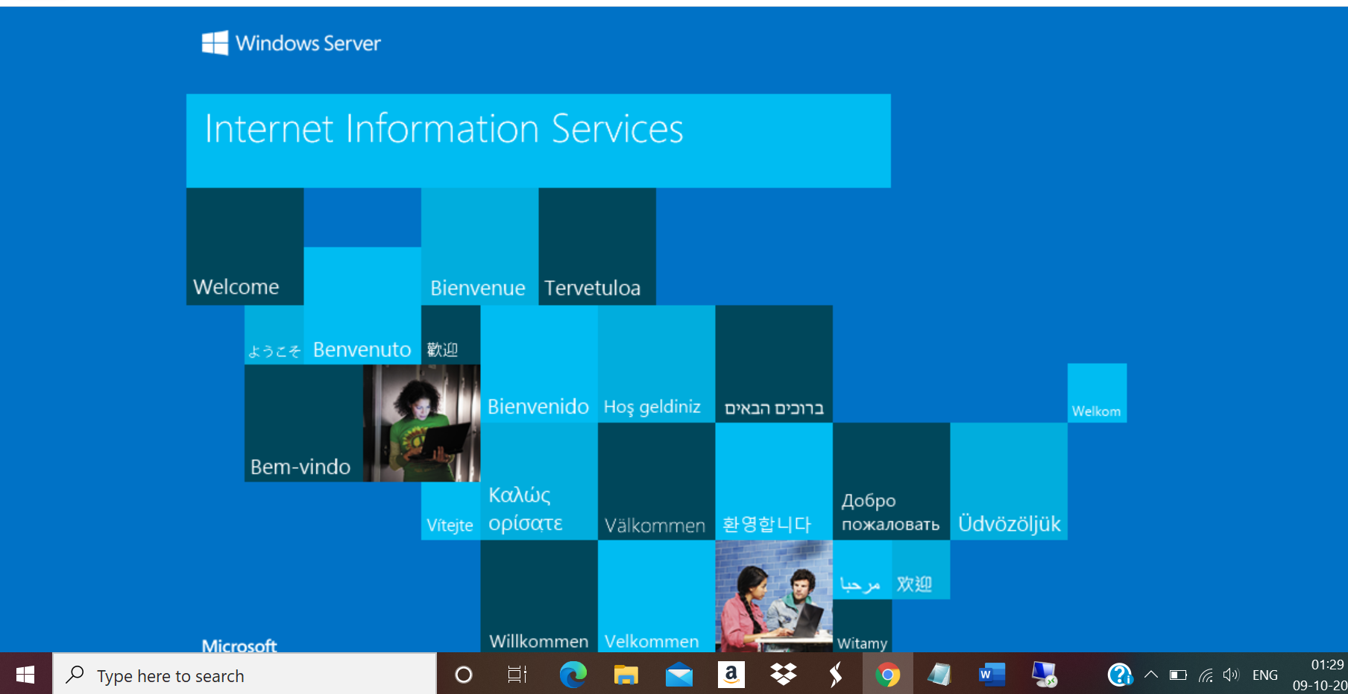

PROJECT 2:

Deploying a web server in Windows instance

Task 1:Create a windows instance using AMI: Ubuntu Server 18.04 LTS (HVM)

Task 2:Download and install MobaXterm Portable Edition

Task 2:Launch the Ubuntu instance using SSH

Task 3:Install Nginx web server using bash

Note: Simply copy the command below and paste in the bash to install the Nginx web server.

sudo apt-get -y update

sudo apt-get -y install nginx

Task 4:Verify successful installation of ngnix

Note: You should be able to see the Welcome to ngnix Web page when you paste the public IP into the

browser.

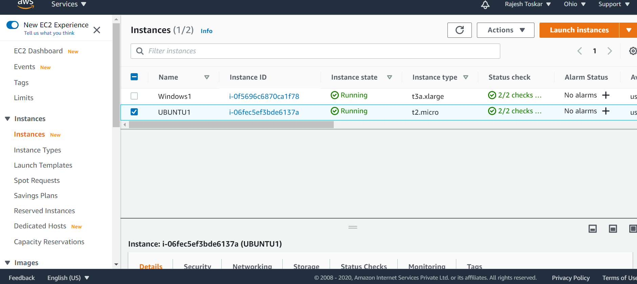

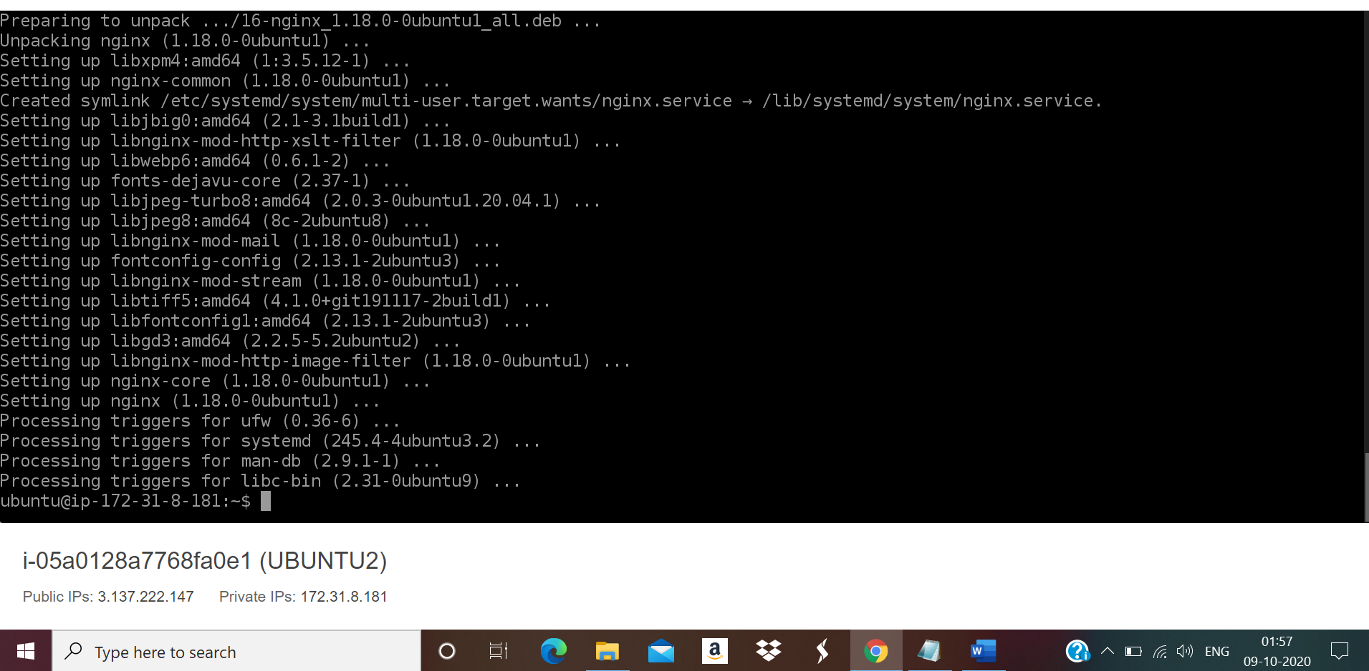

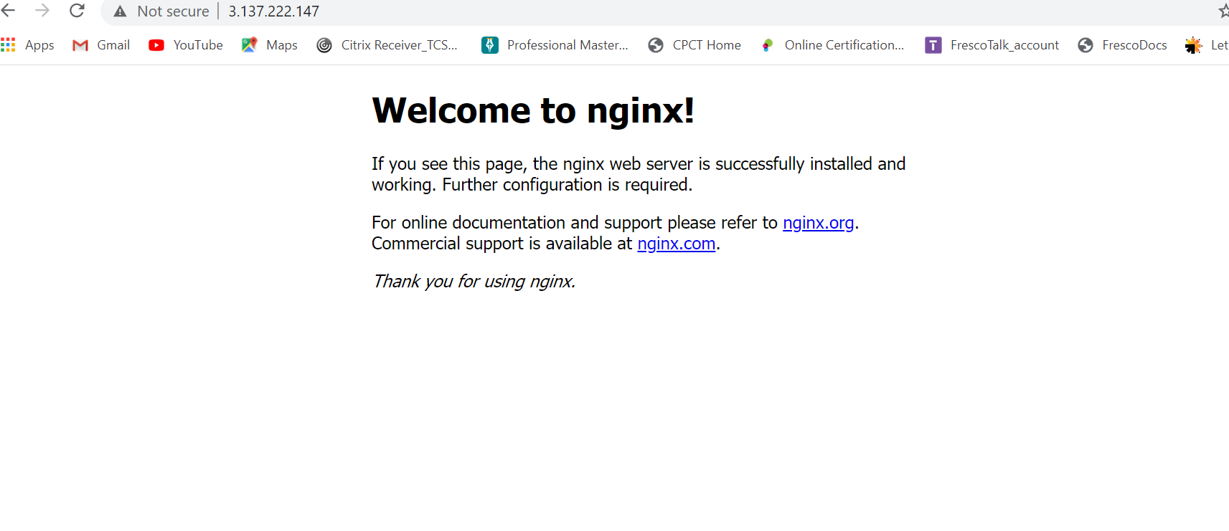

PROJECT 3:

Working with volumes

1:Create a windows machine

2:Create a volume in the same region as the windows machine

3:Attach the volume to the windows machine

4:From server manager bring the volume online

5:Once the ebs is online create a new volume

6:Check if the volume is mounted successfully

7:Try modifying the volume config

8:Delete the volume

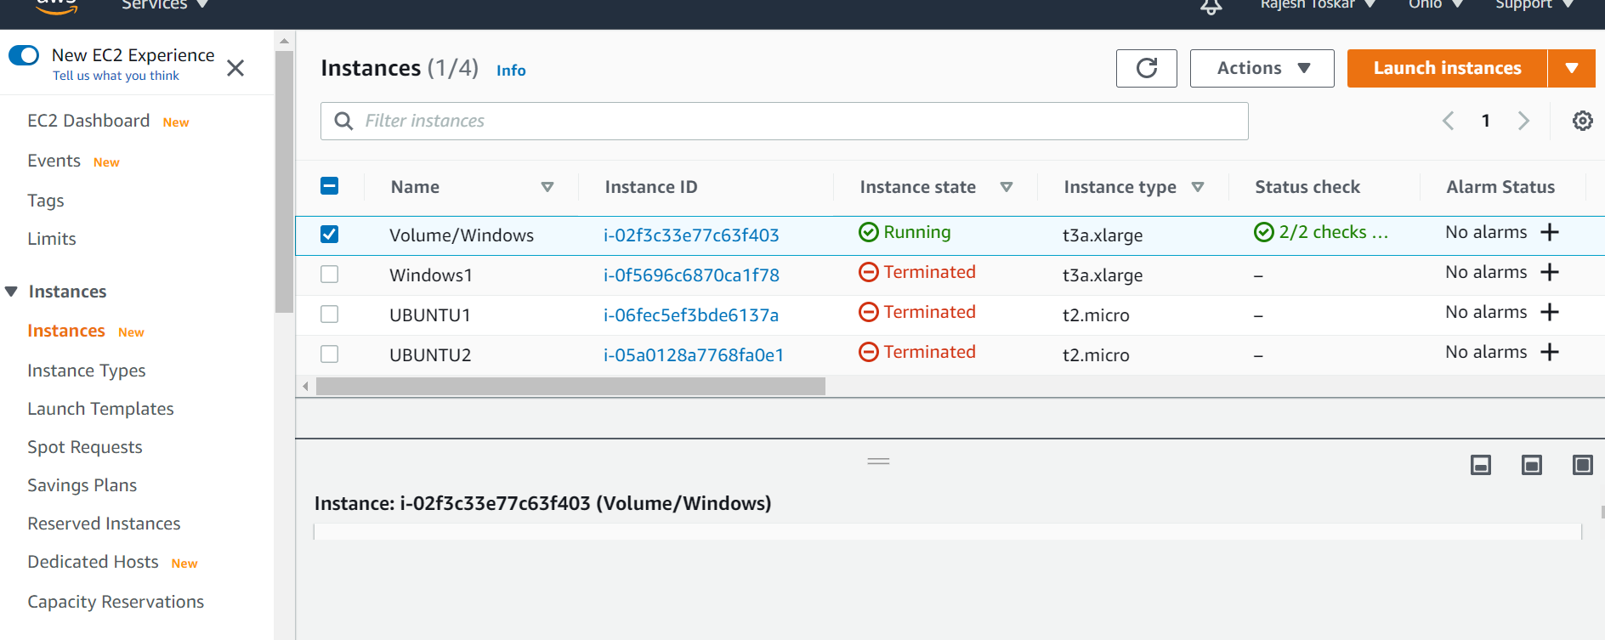

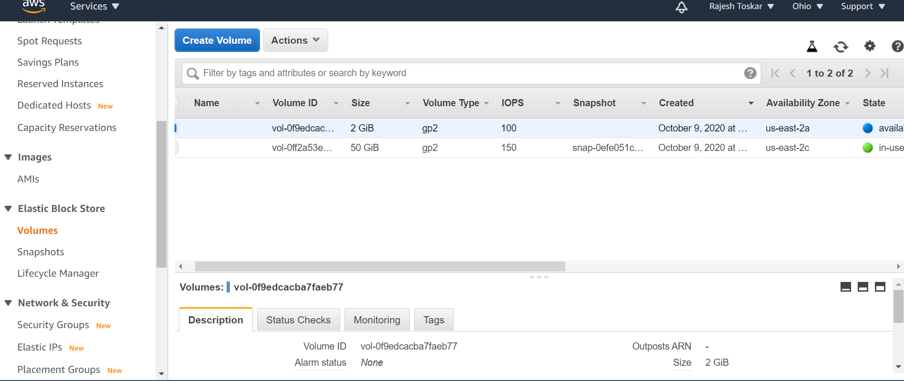

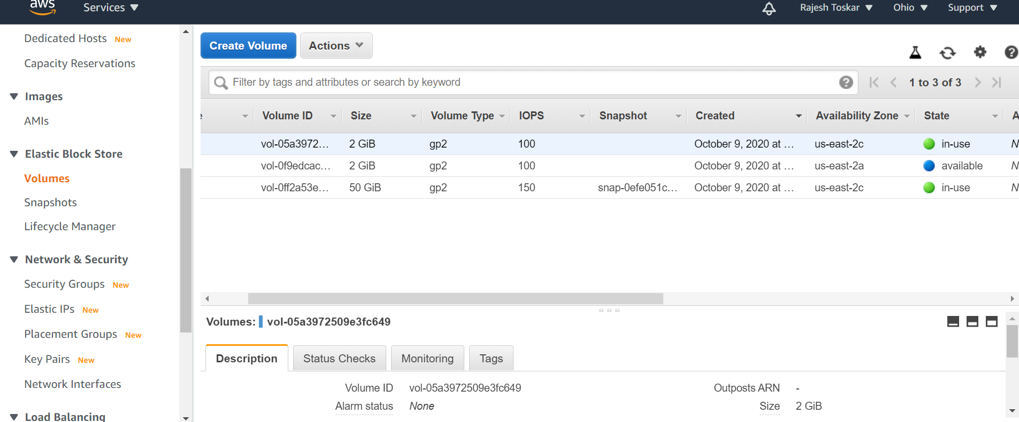

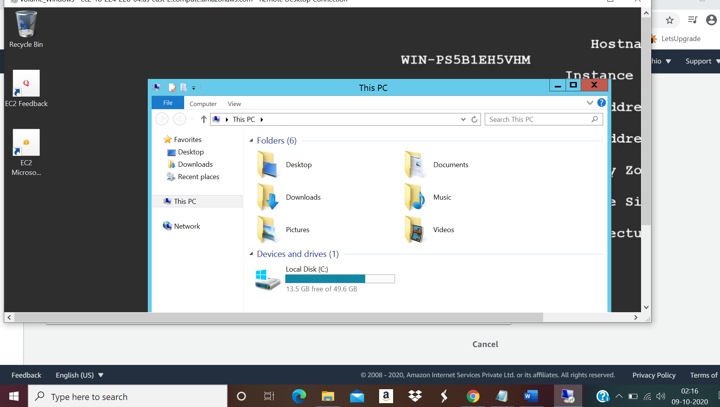

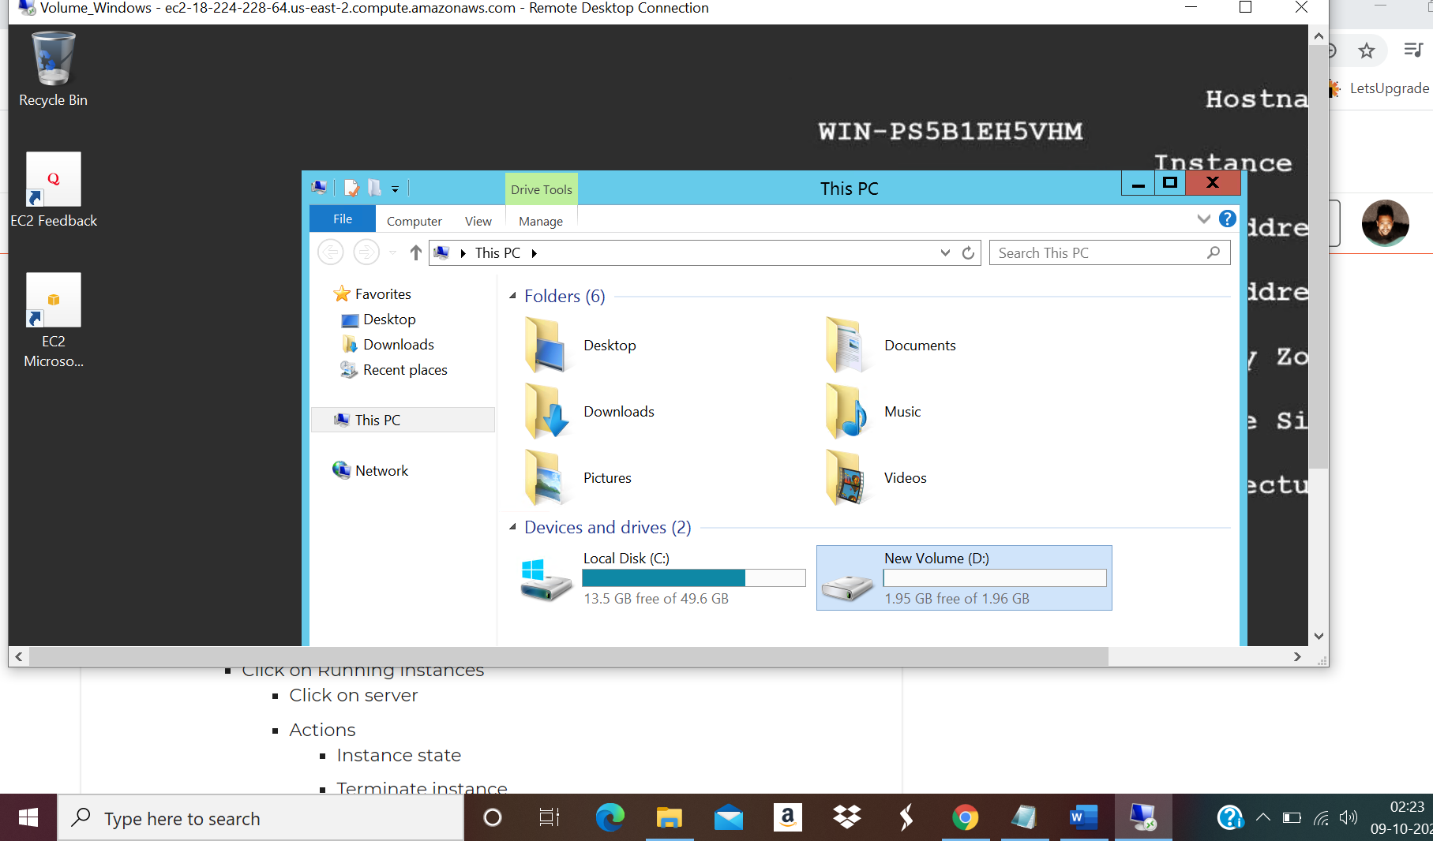

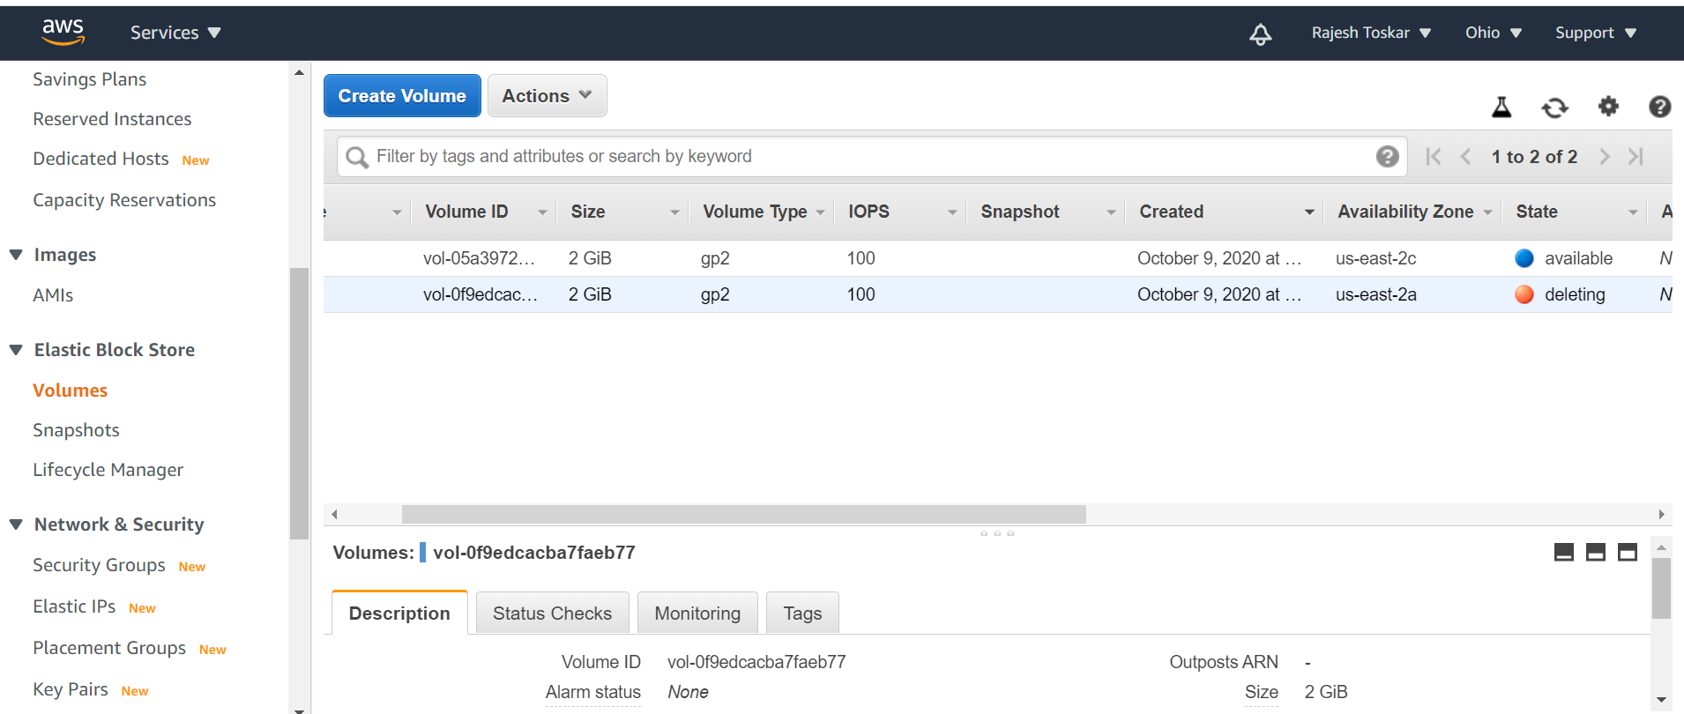

PROJECT 4:

Working with Elastic IP's

Step1: Install an Apache Server

Switch to the root user

sudo -s

Step2: Now run the updates using the following command:

yum -y update

Step3: Once completed, let’s install and run an apache server

Step1: Install the Apache webserver:

yum install httpd

When prompted, press "Y" to confirm.

Step2: Start the webserver

systemctl start httpd

Step3: Now enable httpd:

systemctl enable httpd

Step4: Check the web server status

systemctl status httpd

You can see the active status is running.

You can test that your web server is properly installed and started by entering the public IP address of

your EC2 instance in the address bar of a web browser. If your web server is running you will see the

Apache test page. If you don't see the Apache test page, then verify whether you followed the above steps

properly and check your inbound rules for the security group that you created.

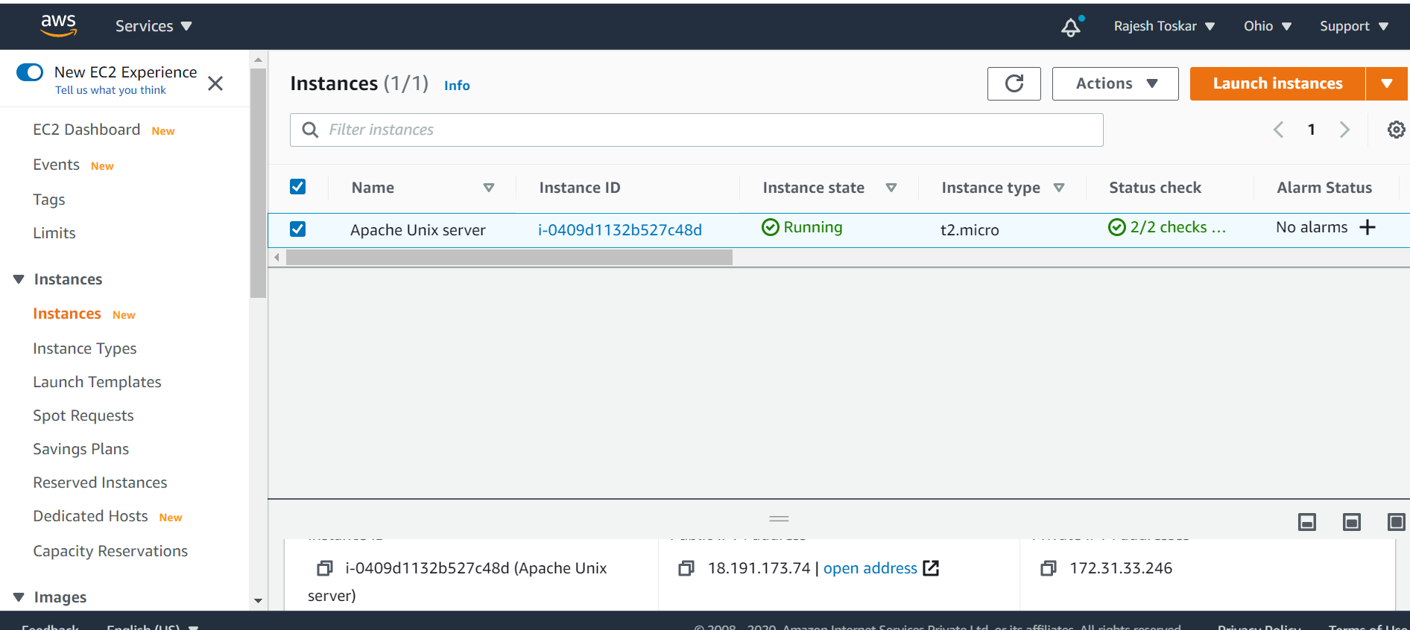

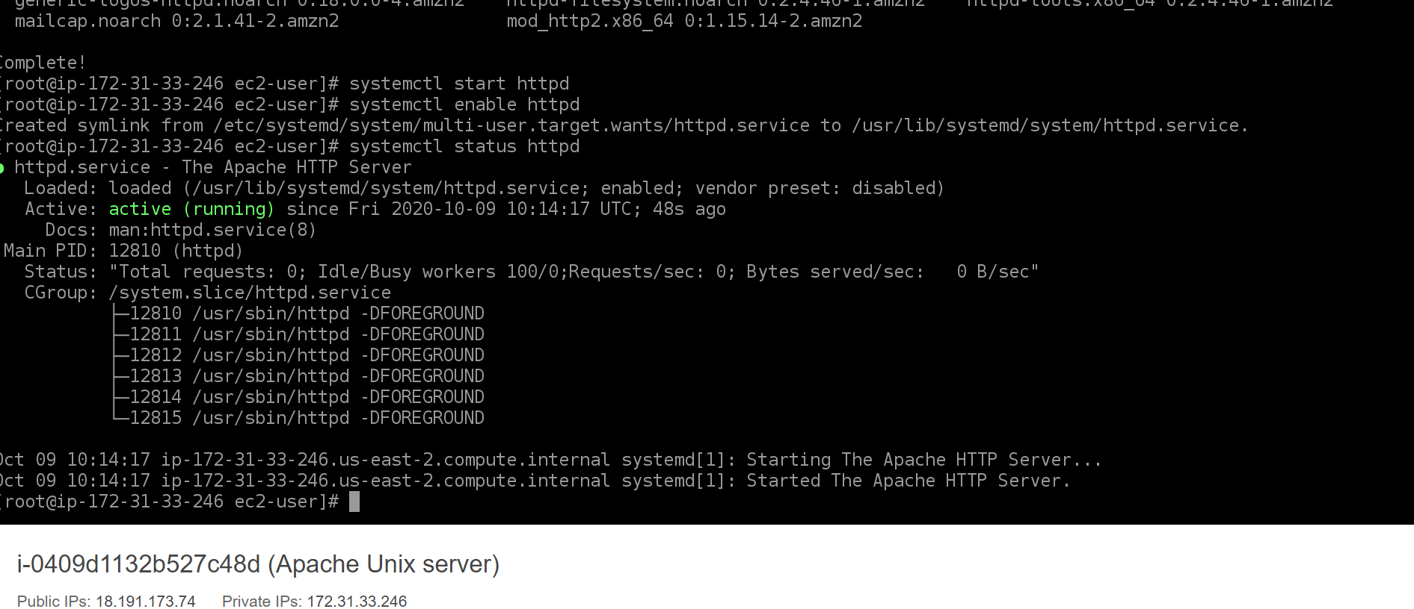

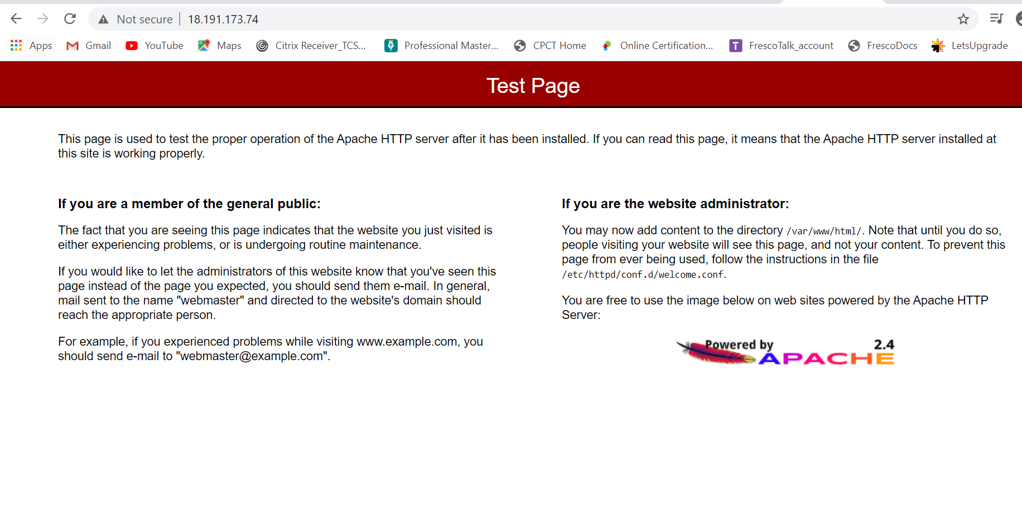

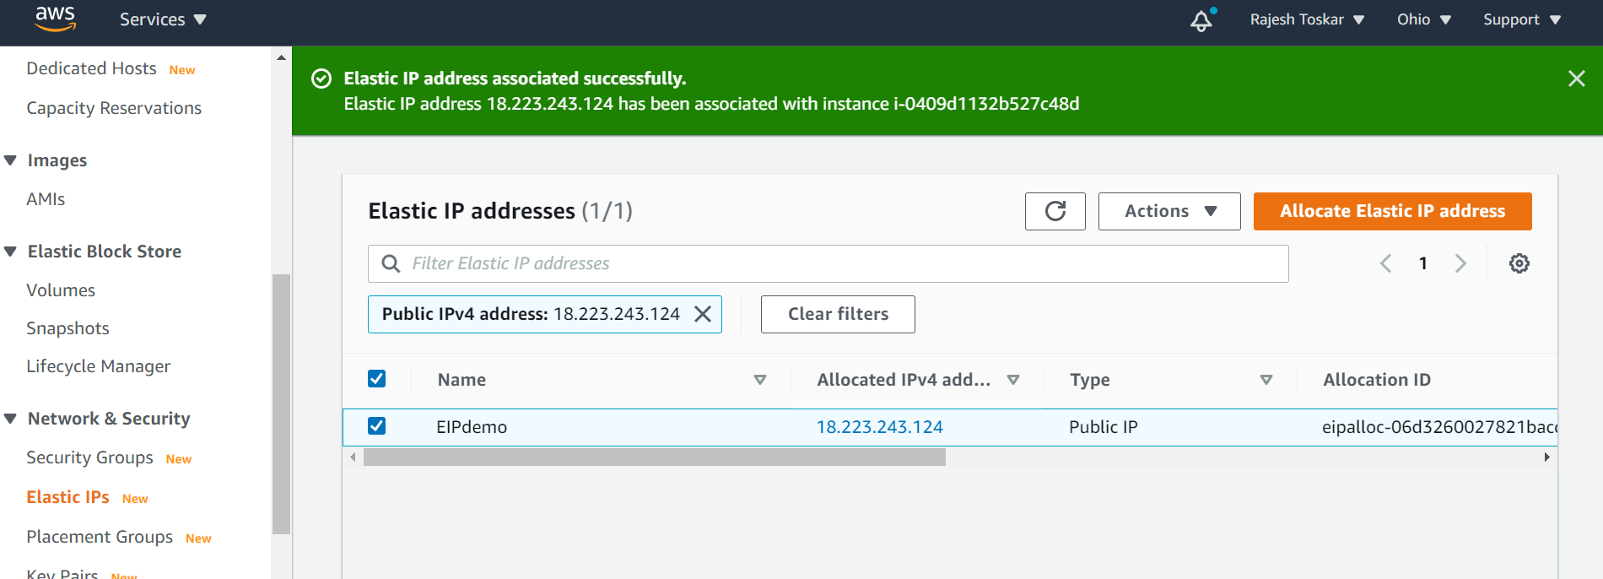

With old public ip :

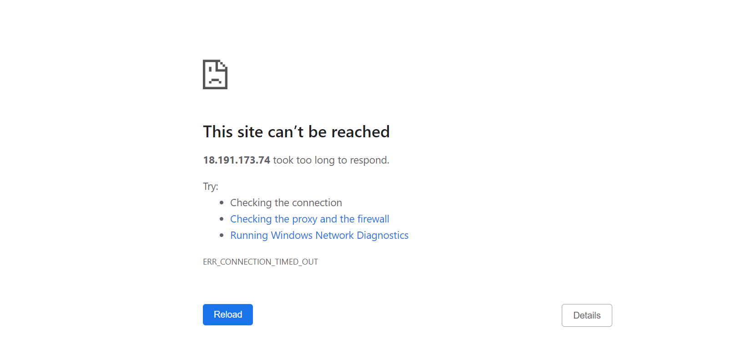

New elastic ip :

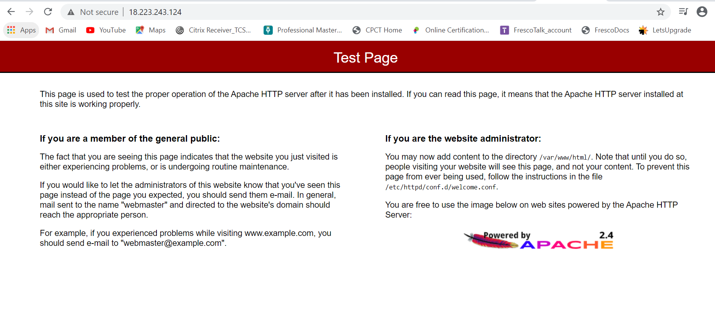

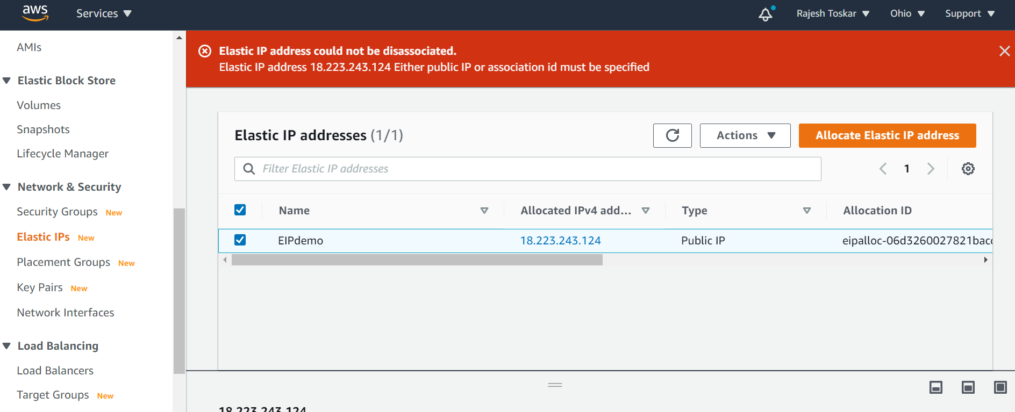

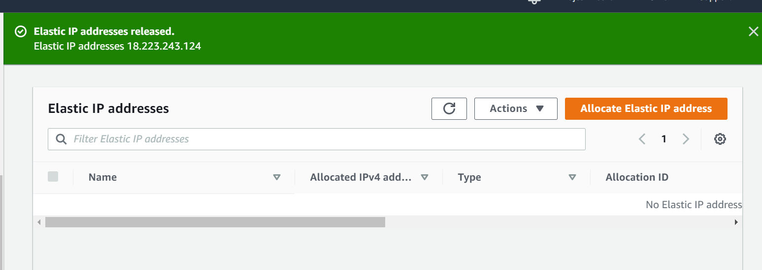

**QUESTION 1: Explain life cycle effects on instances:Stop,start,reboot,terminate-public IP,Private Ip,Applications installed.**

Stop instance – We can stop running instance , it is similar to shutting down the system.We can stop instance if we are using Amazon EBS volume as root device.Amazon don’t charge for the stopping instance.

=====

Start instance – We can start the instance which we have stopped earlier, unlike stop amazon charges for starting a stop instance. The instance retains its instance id.

=====

Reboot instance - An instance reboot is equivalent to an operating system reboot. In most cases, it takes only a few minutes to reboot your instance. When you reboot an instance, it keeps its public DNS name (IPv4), private IPv4 address, IPv6 address (if applicable), and any data on its instance store volumes. It is not chargeble and we can schedule out instance reboot.

====

Terminate instance – We can terminate the instance once we don need to use that instance. Once we terminate the instance , we don’t get charge for it and we no longer used the same instance again that we was able to use in stop-start activities.

====

Public IP - A public IP address is assigned to your instance from Amazon's pool of public IPv4 addresses, and is not associated with your AWS account. When a public IP address is disassociated from your instance, it is released back into the public IPv4 address pool, and you cannot reuse it

A public IP address is an IPv4 address that's reachable from the Internet. You can use public addresses for communication between your instances and the Internet.

====

Private ip - A private IPv4 address is an IP address that's not reachable over the Internet. You can use private IPv4 addresses for communication between instances in the same VPC. An instance's private IP address will never change during the lifetime of that instance

=================================================================================

PROJECT 5:

Working with S3

a.working with S3-.jpg

b.static web hosting

c.Versioning

a.

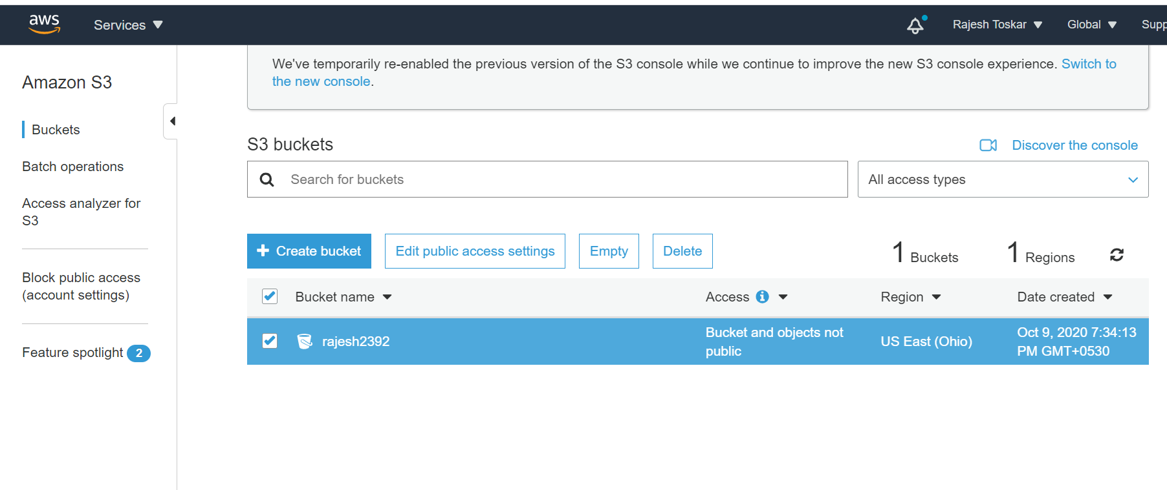

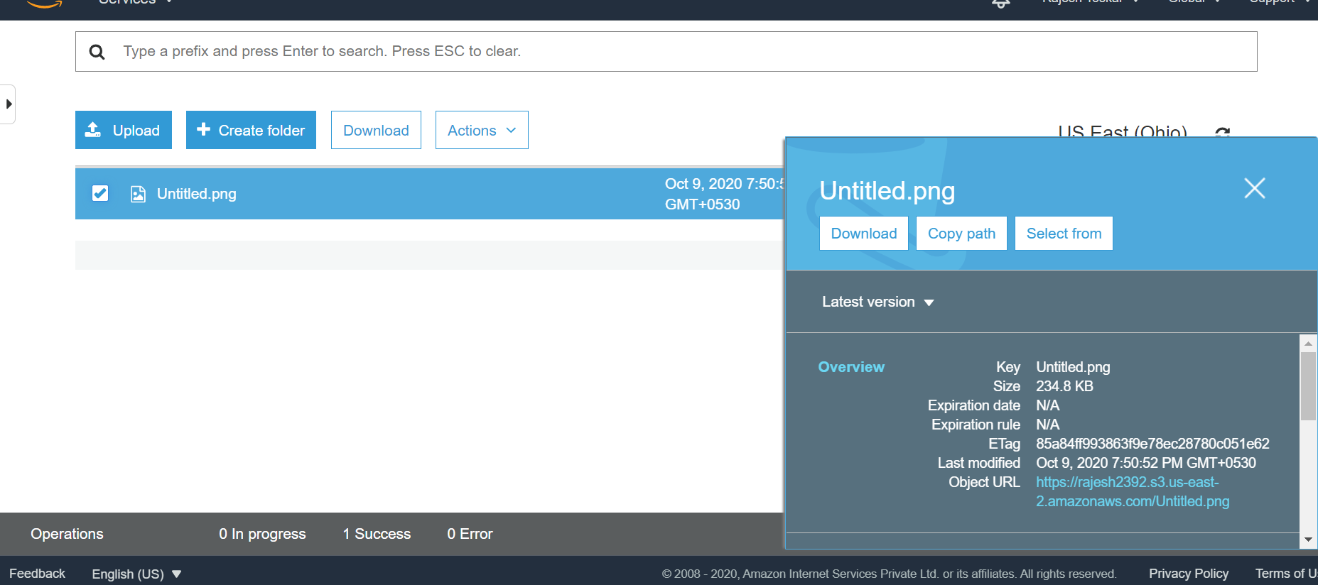

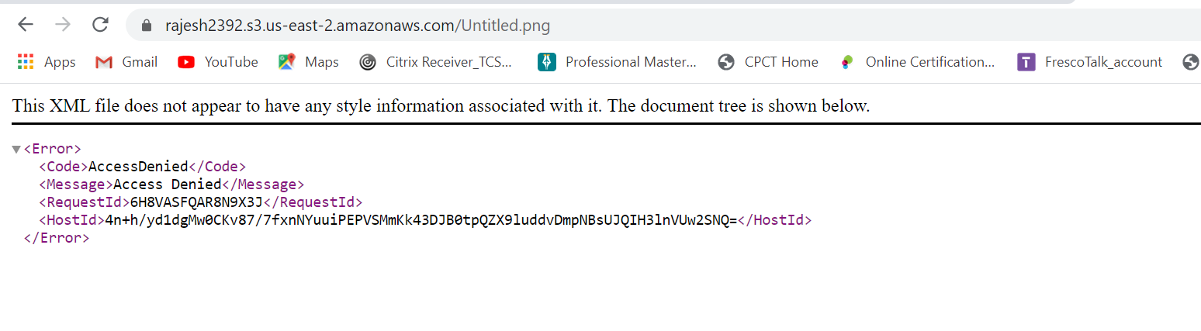

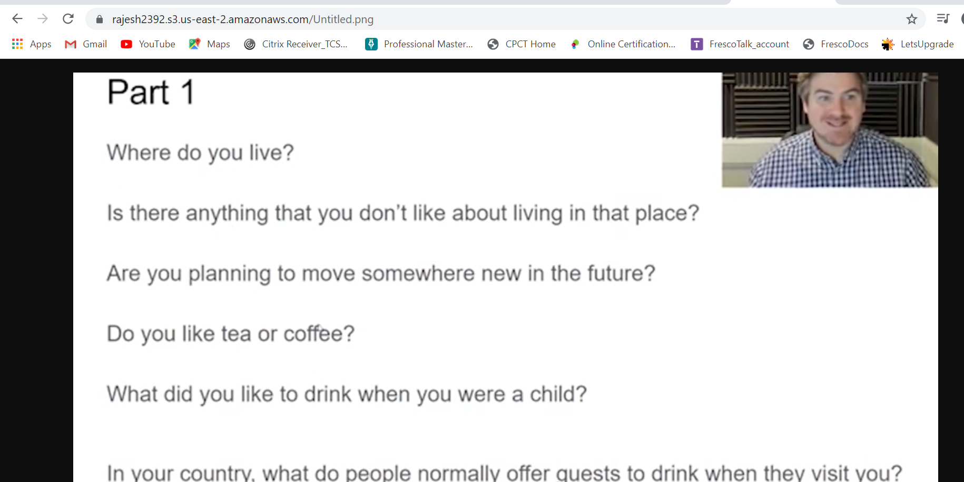

b. static web hosting –

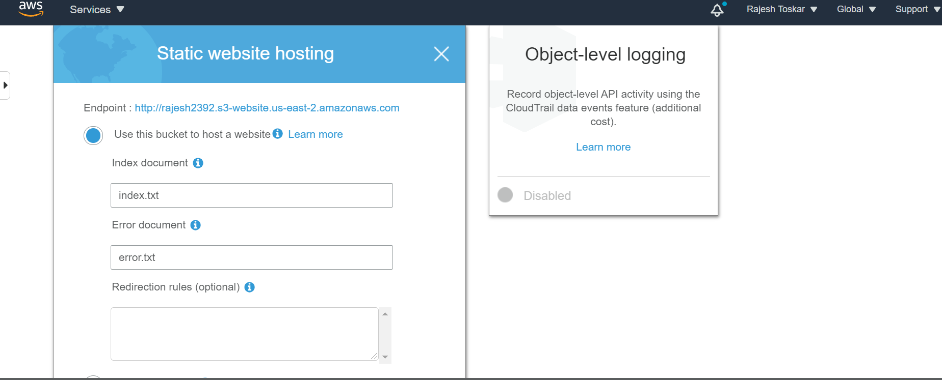

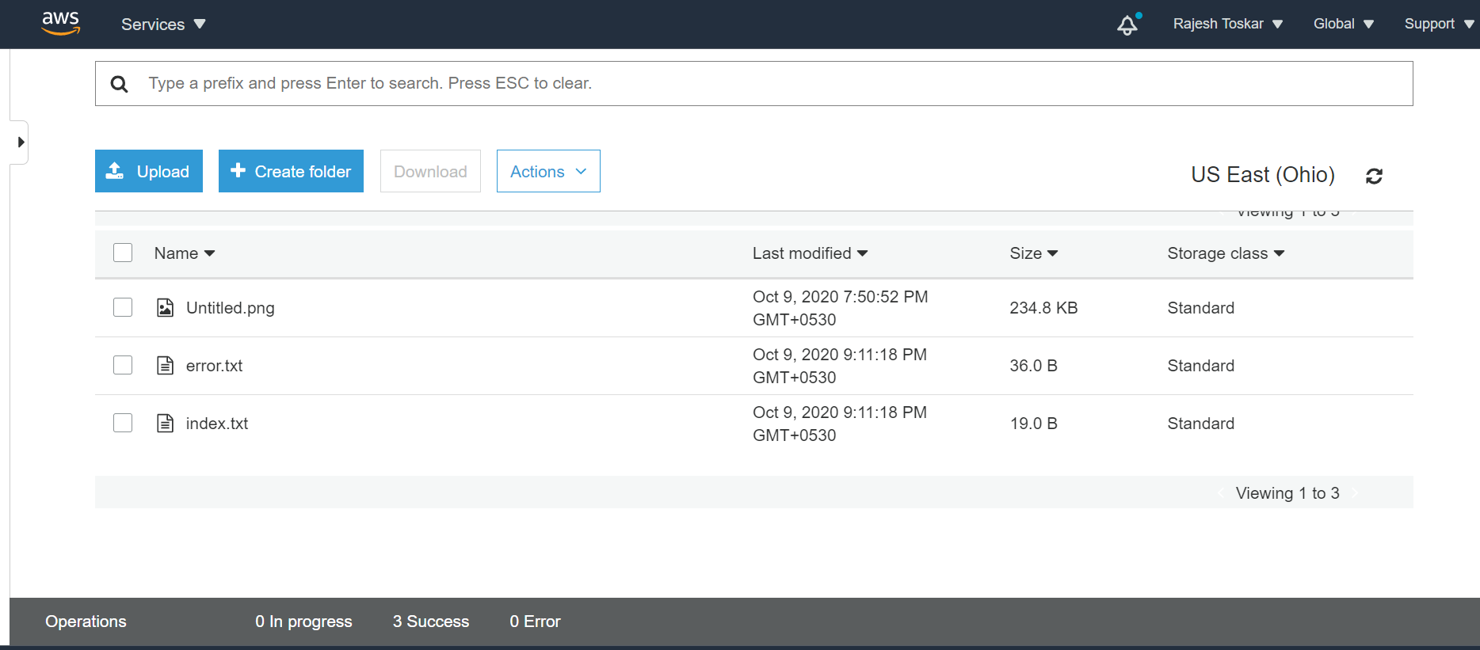

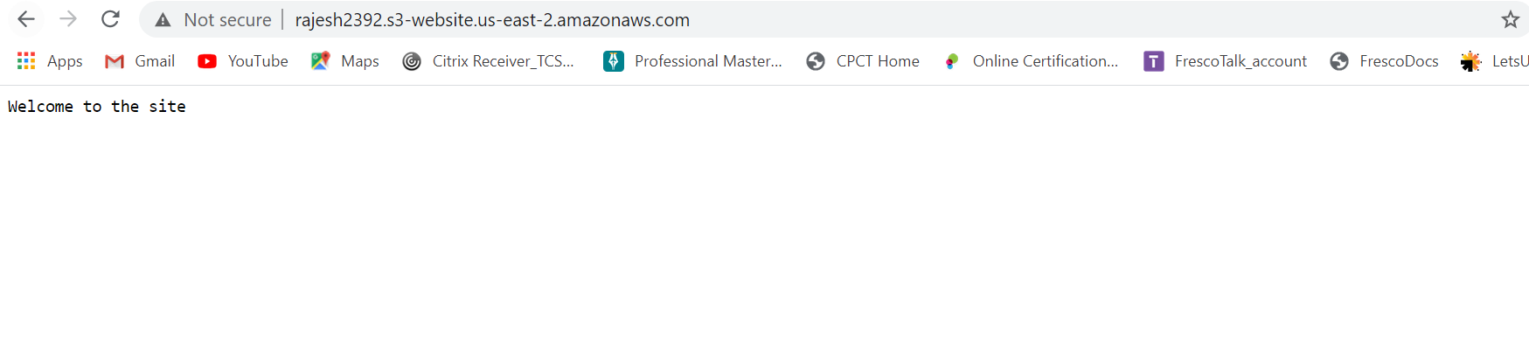

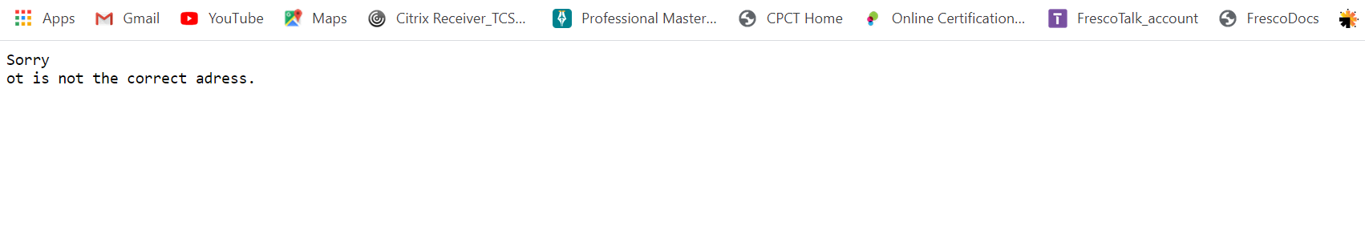

c. Versioning –

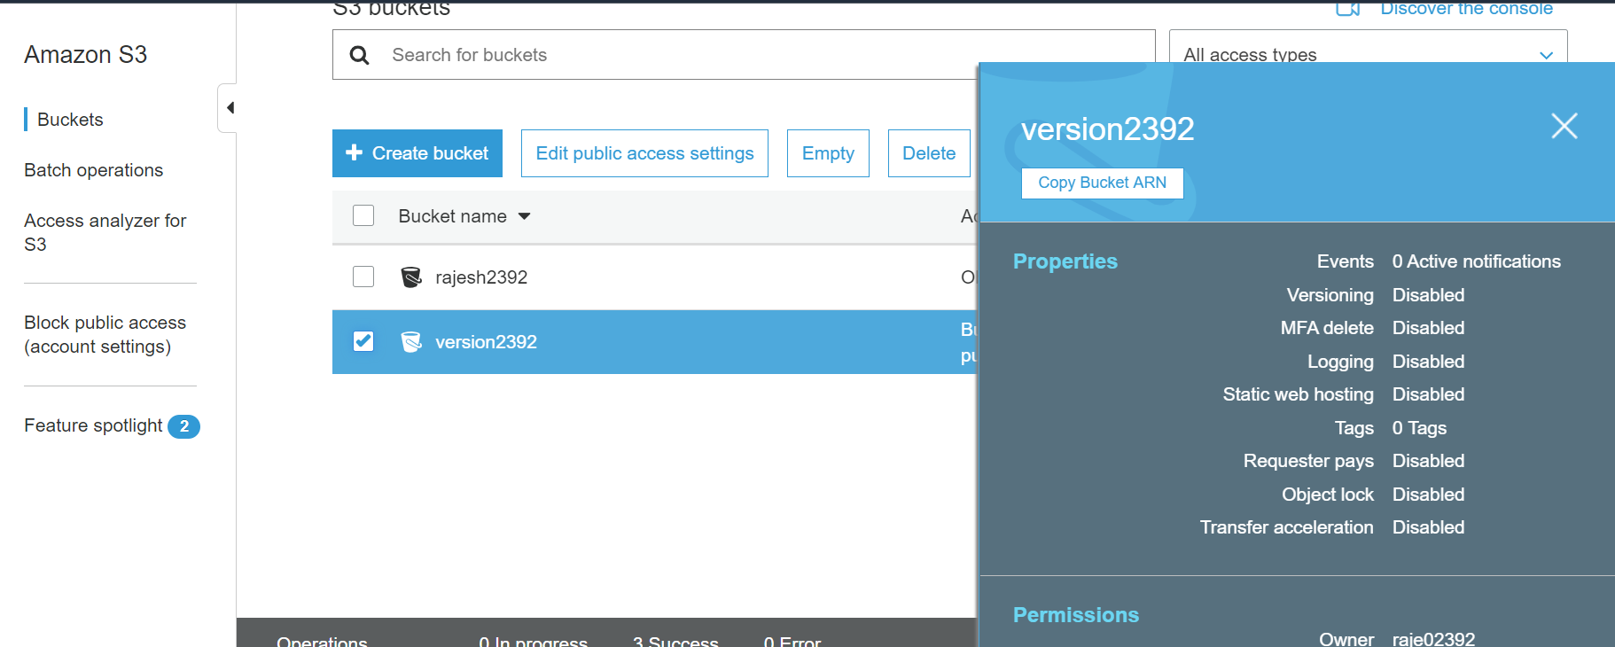

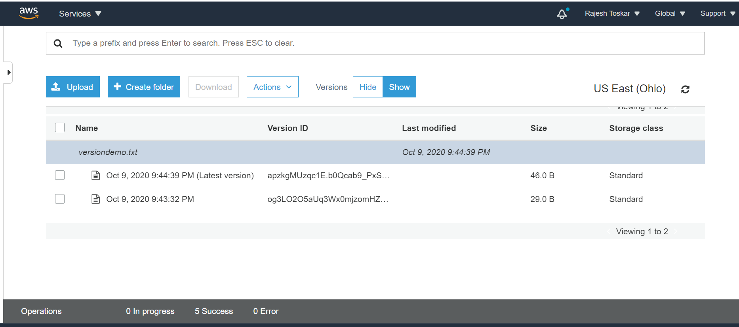

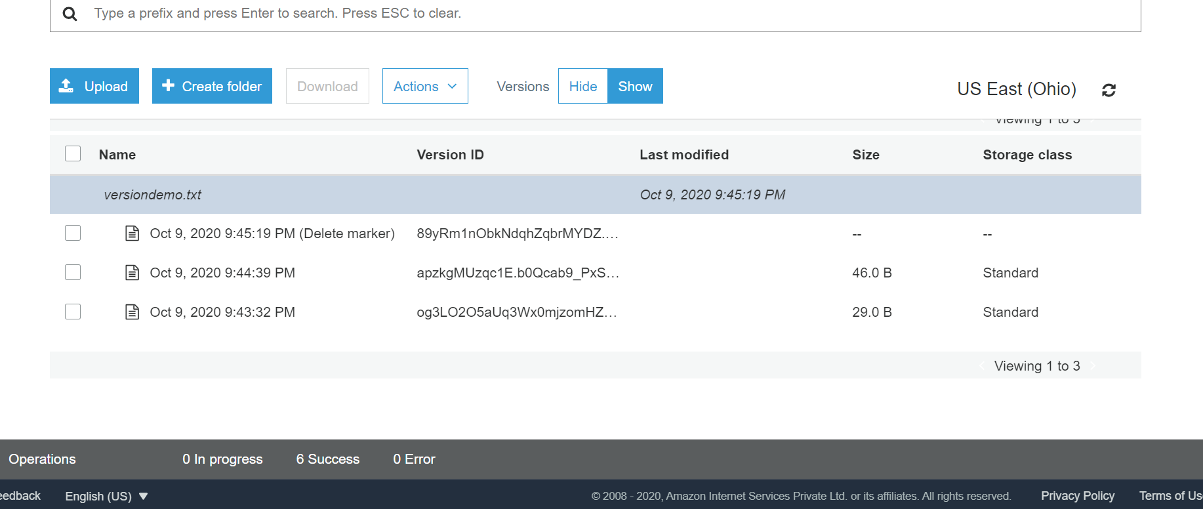

All projects are done and implemented successfully.

Thank you.